Pizza Sales – SQL Queries
- KPI’s

- Total revenue
SELECT SUM(total_price) AS Total_Revenue from pizza_sales;

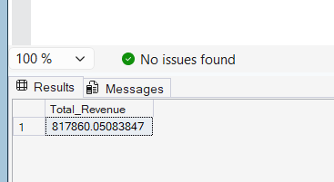

- Average Order Value
SELECT SUM(total_price) / COUNT(DISTINCT order_id) AS Avg_order_Value from pizza_sales

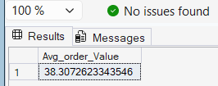

- Total Pizza Sold
Select SUM(quantity) AS Total_Pizza_sold from pizza_sales

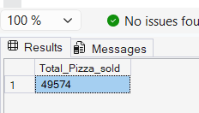

- Total Orders
Select COUNT(DISTINCT order_id) AS Total_Orders from pizza_sales

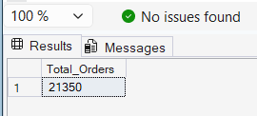

- Average Pizzas per order

SELECT CAST(CAST(SUM(quantity) AS DECIMAL(10,2)) /
CAST(COUNT(DISTINCT order_id) AS DECIMAL(10,2))
AS DECIMAL(10,2))
AS Average_Pizzas_Per_Order from pizza_sales
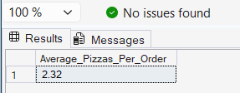

- Daily trend for Total Orders
SELECT DATENAME(DW, order_date) AS Order_Day, COUNT(DISTINCT order_id)
AS Total_Orders from pizza_sales
GROUP BY DATENAME(DW, order_date)
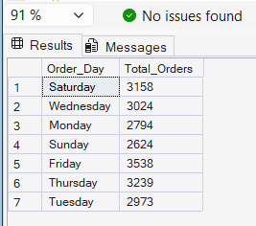

- Monthly trend for Total Orders
SELECT DATENAME(MONTH, order_date) AS Month_name,
COUNT(DISTINCT order_id) AS Total_Orders
from pizza_sales
GROUP BY DATENAME(MONTH, order_date)
ORDER BY Total_Orders DESC
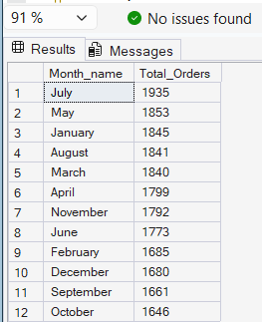

- Percentage of Sales by Pizza Category
SELECT pizza_category, SUM(Total_price) AS Total_sales,
SUM(total_price) * 100 /
(SELECT SUM(total_price) FROM pizza_sales where MONTH(order_date) = 1) AS PCT
FROM pizza_sales
where MONTH(order_date) = 1
GROUP BY pizza_category
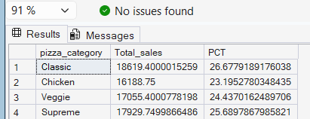

- Percentage of Sales by Pizza Size
SELECT pizza_size, CAST(SUM(total_price) AS DECIMAL(10,2)) AS Total_sales,
CAST(SUM(total_price) * 100 /
(SELECT SUM(total_price) FROM pizza_sales) AS DECIMAL(10,2)) AS PCT
FROM pizza_sales WHERE
DATEPART(quarter, order_date) = 1
GROUP BY pizza_size
ORDER BY PCT DESC
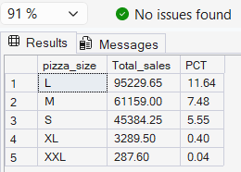

- Top 5 Pizzas by Revenue
SELECT TOP 5 pizza_name, SUM(total_price) AS Total_Revenue FROM pizza_sales
GROUP BY pizza_name
ORDER BY Total_Revenue DESC
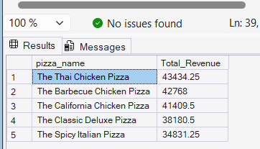

- Bottom 5 Pizzas by Revenue
SELECT TOP 5 pizza_name, SUM(total_price) AS Total_Revenue FROM pizza_sales
GROUP BY pizza_name
ORDER BY Total_Revenue ASC
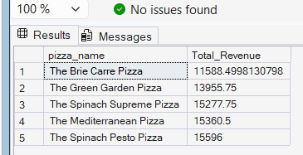

- Top 5 best sellers by Total quantity
SELECT TOP 5 pizza_name, SUM(quantity) AS Total_Quantity FROM pizza_sales
GROUP BY pizza_name
ORDER BY Total_Quantity DESC
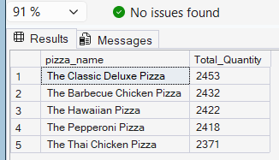

- Bottom 5 best sellers by Total quantity
SELECT TOP 5 pizza_name, SUM(quantity) AS Total_Quantity FROM pizza_sales
GROUP BY pizza_name
ORDER BY Total_Quantity ASC
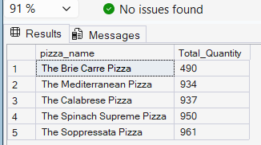

- Top 5 best sellers by Orders
SELECT TOP 5 pizza_name, COUNT(DISTINCT order_id) AS Total_Orders FROM pizza_sales
GROUP BY pizza_name
ORDER BY Total_Orders DESC
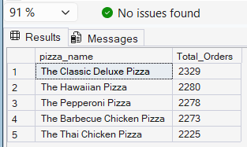

- Bottom 5 best sellers by Orders
SELECT TOP 5 pizza_name, COUNT(DISTINCT order_id) AS Total_Orders FROM pizza_sales
GROUP BY pizza_name
ORDER BY Total_Orders DESC
